A systems architecture design that identifies the leverage points you've identified, the problem, and where in the system your solution is targeting

Screenshot of the architecture design: (I also have it saved as a PDF)
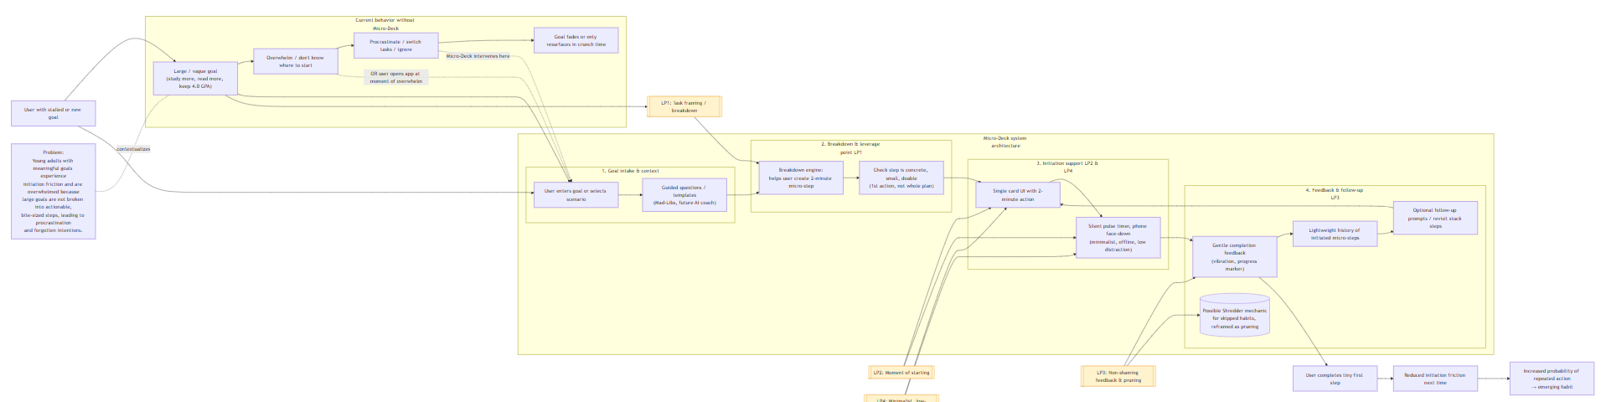
“This diagram zooms into where our solution, Micro‑Deck, actually intervenes in that ecosystem. Starting from the problem of young adults feeling stuck at the first step of big goals, we show the current baseline path of overwhelm and procrastination, then overlay Micro‑Deck’s flow: users input a goal, are guided to break it into a tiny, actionable step, see that step as a single focused card, and use a minimalist timer to initiate action with minimal distraction. The architecture highlights how each component maps directly onto our leverage points—task framing, the moment of initiation, gentle feedback and pruning, and a simple interface—so we’re clearly targeting the specific parts of the system that our research suggests matter most.”

Screenshot of the overall system design diagram: (I also have it saved as a PDF)
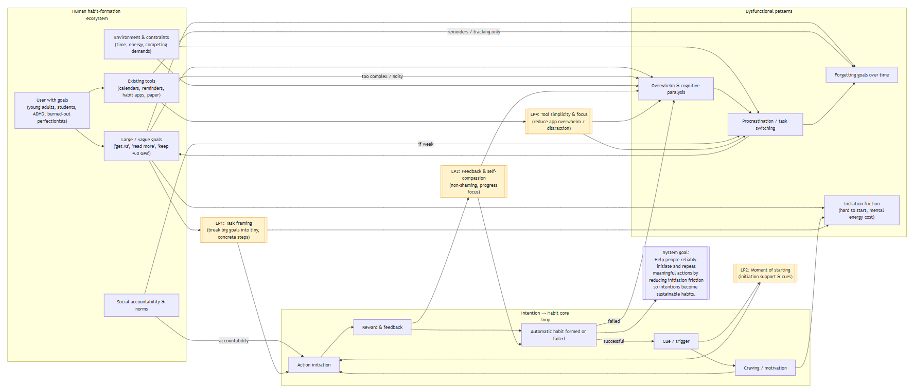
“This diagram shows the broader habit‑formation ecosystem our users live in. People start with meaningful but often vague goals (or tasks), then run into overwhelm, forgetting, and initiation friction, especially when existing tools are either too complex or only track outcomes. Those pain loops feed procrastination and goal fade‑out. The goal of the larger system is to reliably turn intentions into repeatable actions, and we’ve highlighted the key leverage points where small changes can shift behavior: how goals are framed into concrete steps, what happens at the exact moment of starting, how feedback is delivered, and how simple or distracting the tools are.”
Ideas: turn in the system design diagram since it tells a better story about attempting to understand the problem
- I can maybe try simplifying or doing iterations on it (and read over the customer analysis too)
- Is the flow clear?
- Make sure it fits this description: “System design diagram showing ecosystem, elements, relationships, goals, leverage points” (this might get added into the presentation)
  - Have cursor show half of it at a time (kinda like left portion then right portion)

Proposed Solution: Helping people create the habit of breaking down large tasks/goals into actionable, bite-sized pieces

